**DAILY ONLINE ACTIVITIES SUMMARY**

|  |  |  |  |  |  |  |  |
| --- | --- | --- | --- | --- | --- | --- | --- |
| **Date:** | **17-06-2020** | | | | **Name:** | **jaidithya** | |
| **Sem & Sec** | **6 B** | | | | **USN:** | **4AL17CS118** | |
| Online Test Summary | | | | | | | |
| **Subject** | | **PYTHON WORKSHOP TEST** | | | | | |
| **Max. Marks** | | **15** | | **Score** | | **0** | |
| Certification Course Summary | | | | | | | |
| **Course** | **Python workshop- 5days** | | | | | | |
| **Certificate Provider** | | | **-** | **Duration** | | | **5 DAYS** |
| Coding Challenges | | | | | | | |
| **Problem Statement-one java program and one c program.** | | | | | | | |
| **Status:Executed** | | | | | | | |
| **Uploaded the report in Github** | | | | **Yes** | | | |
| **If yes Repository name** | | | | **17-6-20.txt** | | | |
| **Uploaded the report in slack** | | | | **Yes** | | | |

Certification Course Details: (Attach the snapshot and briefly write the report for the same)

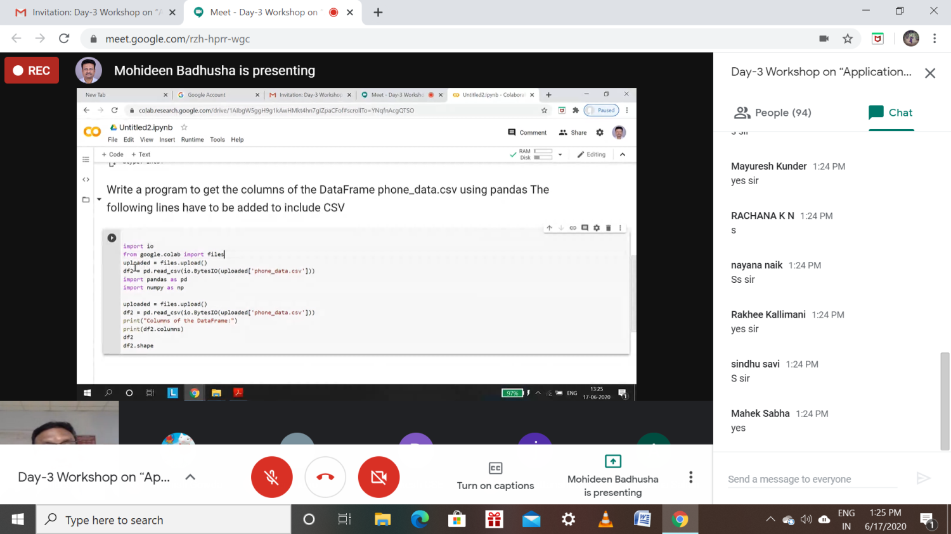



Coding Challenges Details: (Attach the snapshot and briefly write the report for the same)

Program1: 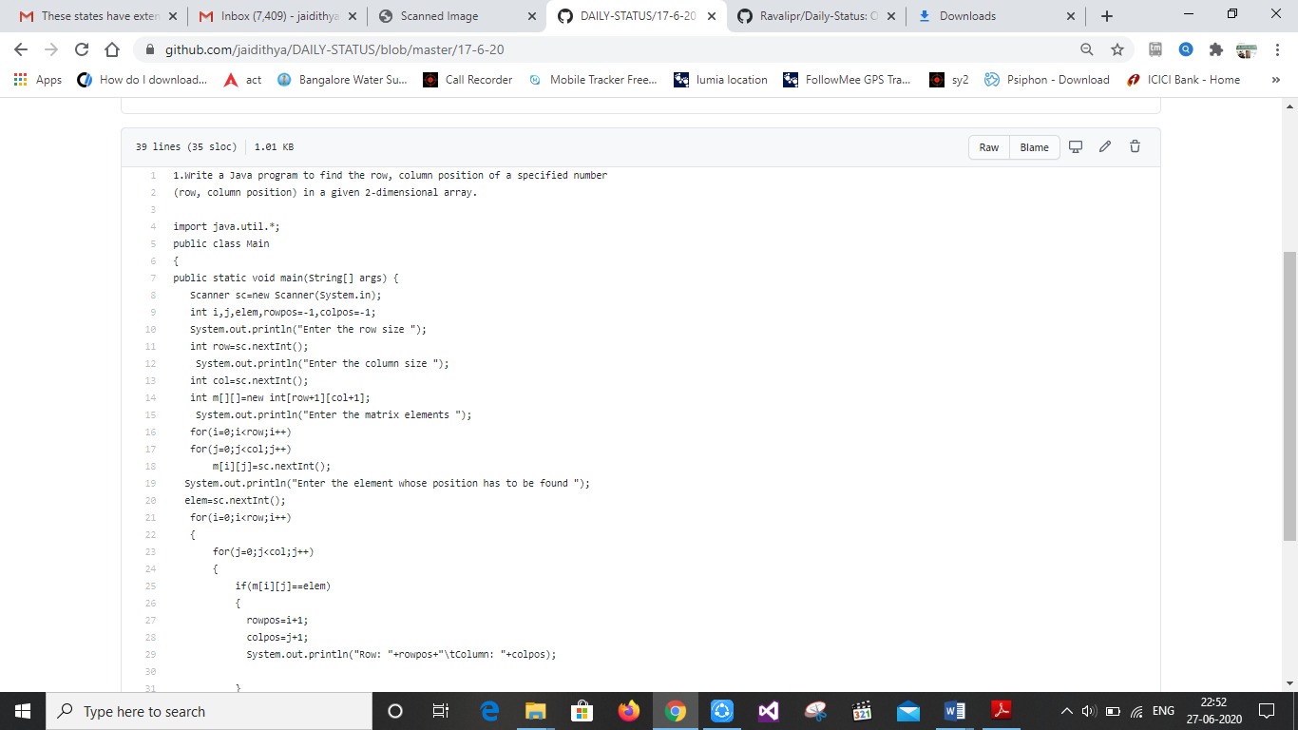

Program2 :

